

ATAR Physics

Year 12 2019

**Task 2: Topic Test 1**

**Gravity and Motion**

Student Name: _______________________________

Weighting: 10%

I acknowledge that all the information contained in this task is my own work and not taken from other sources. If other sources have been used they have been acknowledged in my references.

____________________________________

(Student Signature)

Teacher Comments:

|  |  |  |  |  |
| --- | --- | --- | --- | --- |
| **Time allowed**: 90 minutes + 5 mins reading time. | | | | |
| **Section** | Number of questions | Your Mark | Marks available | Percentage of Test |
| **Section One:** Short answer | 6 |  | 23 | 25 |
| **Section Two**: Extended answer | 6 |  | 52 | 57 |
| **Section Three:** Comprehension  and data analysis | 1 |  | 16 | 18 |
|  | **Total** |  | **91** | **100** |

Please do not turn the page until instructed to do so

**Section One:** Short answer

**Question 1 (2 marks)**

A researcher measured the strength of the gravitational field (*g*) of an object of mass (*m*) at a range of distances (*r*) from the object and plotted the inverse of the square of the distance from the object against gravitational field strength. The graph below shows the plot.

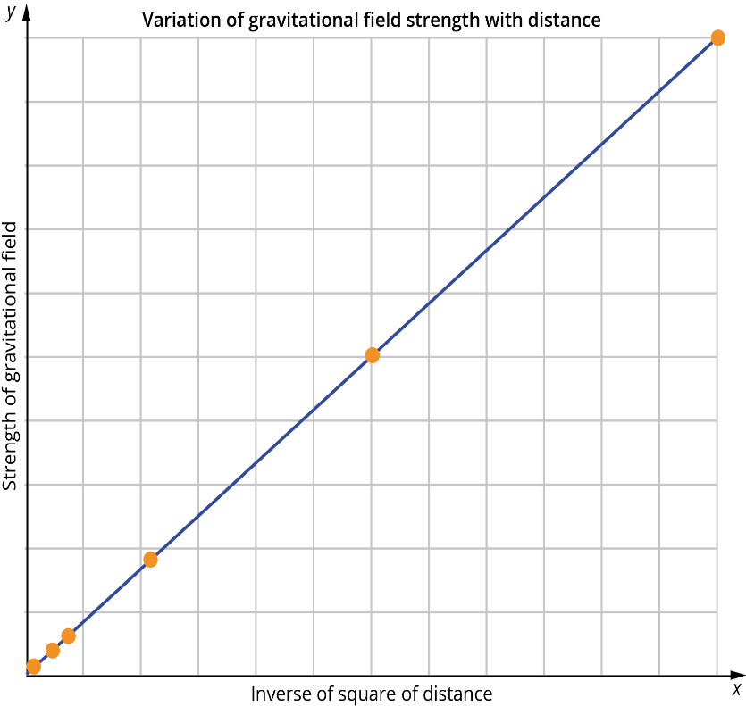Describe what the shape of the graph indicates about the relationship between gravitational field strength and distance from the object.

|  |  |
| --- | --- |
| **Description** | **Marks** |
| Recognition only that as distance from the object increases the gravitational field strength decreases | 1 |
| For full marks, recognition that there is a linear relationship between field strength and inverse square of distance  (i.e. ) | 2 |

**Question 2**

At the Australia Day fireworks in Perth, a firework rocket is launched at an angle of 85° to the horizontal.

1. At what initial velocity at the stated angle does the rocket need to be fired to reach a maximum height of 750 m if it starts from the ground? **(4 marks)**

|  |  |  |
| --- | --- | --- |
| **Description** | | **Marks** |
| Vertical component of velocity:  *v*2 = *u*2 + 2*as*  0 = *u*2 + 2 × −9.8 × 750  *u*2 = 1.47 × 104  *u* = 1.21 × 102 m s–1 | | 1  1 |
| Component of velocity at 85°: | | 1  1 |
| Thus, |  |

1. The firework technician needs to set the timer for the explosion so that it will explode at the maximum height. For how long must set the timer be set? **(2 marks)**

|  |  |  |
| --- | --- | --- |
| **Description** | | **Marks** |
| *v*v = *u* + *at* | | 2 |
| Thus, |  |

**Question 3 (4marks)**

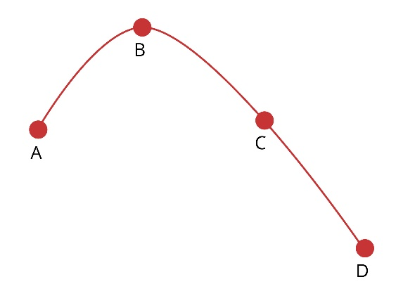

The diagram right shows the path travelled by a shot-put, from A to D, after it has been thrown by a competitor from a height of 1.92 m.

On the axes provided, sketch the vertical component of velocity against time as it travels from the competitor’s hand until it strikes the ground. On your graph mark the points A, B, C and D that correspond to these points on the curve. Other labels can be used to assist if needed.

**(4 marks)**

|  |  |
| --- | --- |
| **Description** | **Marks** |
| Straight line decreasing with time or increasing from negative depending on direction convention used. | 1 |
| A and C being opposite signs but equal magnitude | 1 |
| B zero | 1 |
| D opposite sign to A and greater magnitude | 1 |

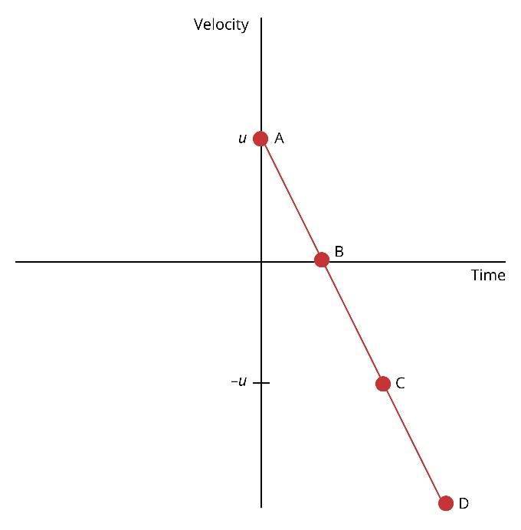

Question 4

Astronauts in training for weightlessness are given some practice in a plane, which flies in vertical loop of radius 600 m at such a speed that at the top of the path they feel “weightless”. At what speed must the plane be flying to achieve this effect? Explain your logic using appropriate equations or vectors. **(4 marks)**

|  |  |
| --- | --- |
| **Description** | **Marks** |
| When weightless Fn = zero | 1 |
| Fc = Fn + Fw  therefore Fc = Fw | 1 |
| mv2/r = mg  v = √gr | 1 |
| v= √ 9.8 x 600  v = 76.7 ms-1 | 1 |

**Question 5**

The diagrams below show designs for two vases. The centre of mass, G, is marked on each.

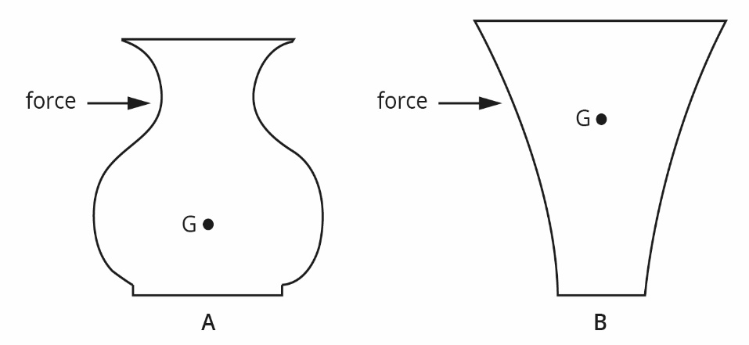

State which of the two vases is more stable and therefore least likely to be tipped over. Using the diagrams and appropriate physics principles, explain your answer. **(4 marks)**

|  |  |
| --- | --- |
| **Description** | **Marks** |
| Vase A is more stable. | 1 |
| For B, the distance / angle through which it must travel to reach the point when G is outside the base is less than it is for A. | 1 |
| At the point where G is outside the base, there is a clockwise moment about the pivot which will cause the vase to tip over. | 1 |
| Appropriately labelled lines | 1 |

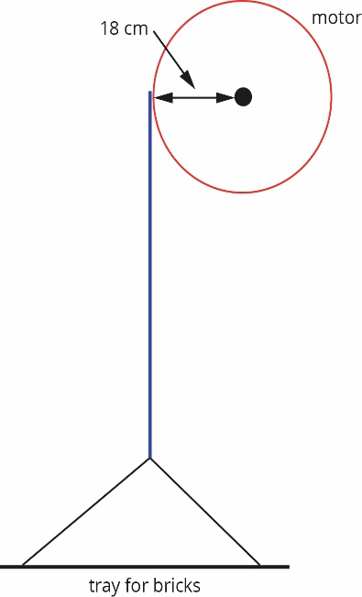**Question 6**

At a building site, a pulley system operated by an electric motor is used to lift bricks to the upper floors of the building. The motor can supply a torque of 750 N m. The pulley operated by the motor has a radius of 18 cm. The diagram below shows the system.

What is the maximum mass of bricks the winch can lift? **(3 marks)**

|  |  |
| --- | --- |
| **Description** | **Marks** |
| τ = *rF* | 1 |
|  | 1 |
|  | 1 |

**Section Two** Extended answer

**Question 7**

While conducting an experiment in a plane, a student uses a set of scales to measure the force of the gravitational field on a 7.50 kg object. The scales give a reading of 73.1 N.

1. What is the strength of the gravitational field acting on the object? **(3 marks)**

|  |  |
| --- | --- |
| **Description** | **Marks** |
|  | 1 |
|  | 2 |

1. Determine the altitude at which the plane is flying in order to provide the measurement taken.

**(5 marks)**

|  |  |
| --- | --- |
| **Description** | **Marks** |
| Recognition that at heights above the Earth’s surface the gravitational field strength is calculated using: | 1 |
|  | 1 |
|  | 2 |
| Height above Earth’s surface = 6.39 × 106 − 6.38 × 106   = 1.07 × 104 m  NOTE – Answer will be 1.18x104 m is full force formula is used instead of gravitational field strength. | 1 |

**Question 8**

Thomas, who has a mass of 43.6kg, slides down the banister at his grandparents’ house. The banister makes an angle of 35º with the horizontal and provides a frictional resistance.

1. Draw a labelled free body diagram of the above situation showing all the forces involved.

**(3 marks)**

|  |  |  |
| --- | --- | --- |
| **Description**  Weight Force  Friction |  | **Marks** |
| 1 Mark each  -1 for additional forces or components  Normal Force |  |  |
|  | **Total** | **3** |

1. What is the normal force between Thomas and the banister? **(2 marks)**

|  |  |  |
| --- | --- | --- |
| **Description** |  | **Marks** |
| Fn = Fw x cosᶿ  Fn = 43.6x9.8xcos 35 |  | 1 |
| Fn = 350 N perpendicular to plane. |  | 1 |
| http://mcat-review.org/inclined-plane.gif | **Total** | **2** |

1. If the railing provides a frictional resistance of 110N, what is the net force down the banister?

**(3 marks)**

|  |  |  |
| --- | --- | --- |
| **Description** |  | **Marks** |
| Fdownslope = Fw x sin ᶿ  Fdownslope = Fw x 43.6x9.8 x sin 35 |  | 1 |
| http://mcat-review.org/inclined-plane.gifFdownslope = 245 N down the bannister. |  | 1 |
| Net Force = 245 – 110 = 135N |  | 1 |
|  | **Total** | **3** |

1. What is Thomas’s net acceleration down the banister? **(2 marks)**

|  |  |  |
| --- | --- | --- |
| **Description** |  | **Marks** |
| F = ma  135 = 43.6 x a |  | 1 |
| a = 3.10 ms-2 |  | 1 |
|  | **Total** | **2** |

1. How fast is tom moving at the bottom of the 5.00 m length of bannister, assuming he started from rest? **(2 marks)**

|  |  |  |
| --- | --- | --- |
| v2  = u2 + 2as |  | 1 |
| v2  = 2 x 3.096 x 5.0 v2 = 30.96 v = 5.56 ms-1 |  | 1 |
|  | **Total** | **2** |

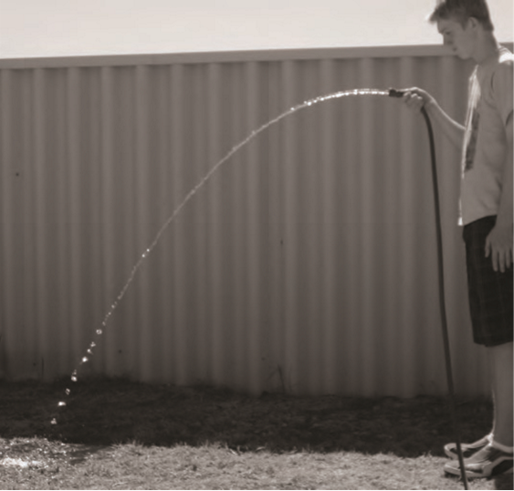**Question 9**

Michael is watering the lawn and wants to estimate the initial velocity of the water coming from the hose.

1. Use information from the photograph to estimate the magnitude of the initial velocity of the water. Express your answer to an appropriate number of significant figures. **(5 marks)**

|  |  |  |
| --- | --- | --- |
| **Description** |  | **Marks** |
| Estimate initial height 1.5 m  Estimate distance = 1.5 m  (accept 1–2 m as 2 sig fig) |  | 1 |
| s = ut + ½ at2 (1 mark using an appropriate formula with uv = 0) |  | 1 |
| 1.5 = 0t + ½ 9.8t2  t = √(2 × 1.5/9.8) = 0.55 s (accept 0.45 s to 0.63 s) |  | 1 |
| v = s/t = 1.5/0.55 = 2.7 m s-1  (2.2 to 3.1 acceptable) |  | 1 |
| (1 mark answer to **two significant figures**) |  | 1 |
|  | **Total** | **5** |

1. Assuming a new pressure results in a velocity of 2.50 m s-1 , how far would the water land from Michael if the hose was held 90.0 cm above ground and pointed upwards 40.0 degrees?

**(5 marks)**

|  |  |  |
| --- | --- | --- |
| **Description** |  | **Marks** |
| Components  vh = cos 40x2.5 = 1.9151 ms-1  vv = sin 40 x 2.5 = 1.60697 ms-1 |  | 1 |
| Down +ve  v2 = u2 + 2as  v = √(-1.606972 + 2 x 9.8 x 0.900)  v = 4.497 ms-1 down |  | 2 |
| t = (v-u)/a  t = (4.497 – (-1.60697))/9.8  t = 0.6228 s |  | 1 |
| sh = vh x t  sh = 1.9151 x 0.6228 = 1.19 m |  | 1 |
|  | **Total** | **5** |

**Question 10**

1. The radius of a curved section of road is 35 m. At what angle should the road be banked to allow drivers to safely take the curve at the speed limit of 80 km h−1 and without needing to rely on the friction between the road and tyres?

Support your answer with a labelled free body diagram to show the forces and their net force involved. **(4 marks)**

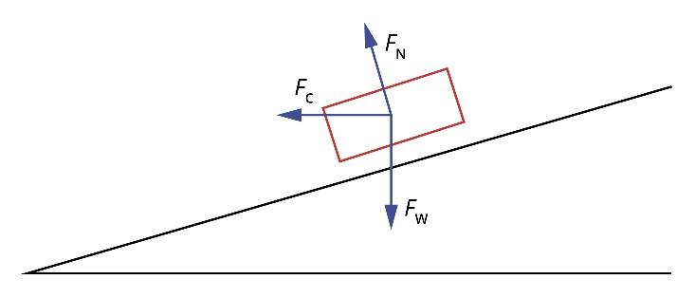

|  |  |
| --- | --- |
| **Description** | **Marks** |
| Diagram Fn + Fw + Fc (net) drawn in correctly | 1 |
| *v* = 80 km h−1 = 22.2 m s–1 | 1 |
|  | 1 |
| Thus, θ = 55.2° | 1 |

1. If the mass of the vehicle is doubled, how would this effect the maximum speed possible around the corner? Justify your answer using the formulae used in part a).

**(3 marks)**

|  |  |
| --- | --- |
| **Description** | **Marks** |
| No change in maximum speed | 1 |
|  | 1 |
| Masses cancel out so have no effect on other variables. | 1 |

**Question 11**

A bed consists of a uniform support base for the mattress, the bedhead and the end of the bed. The support base slots into metal supports on the bedhead and end of the bed, as shown in the diagram below. The bed has a length of 2.00 m, a uniform 20.00 kg mattress and the base has a mass of 50.00 kg.

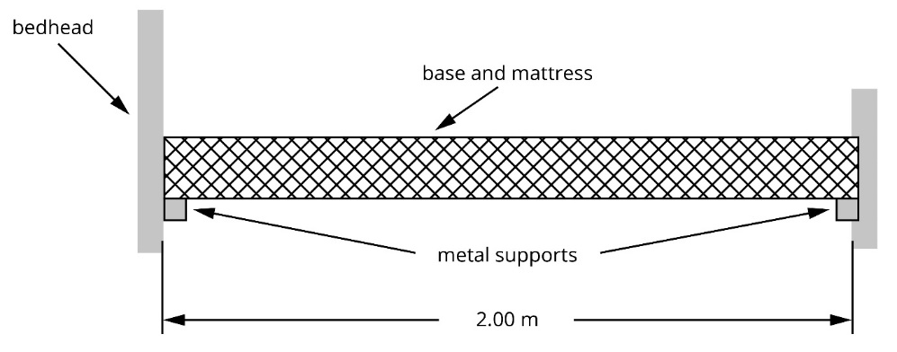

1. If the centre of mass of a 65.0 kg person sleeping in the bed is 30.0 cm from the bed’s centre of mass, calculate the force provided by the metal support at the bed head? Give your answer to the correct number of significant figures. **(3 marks)**

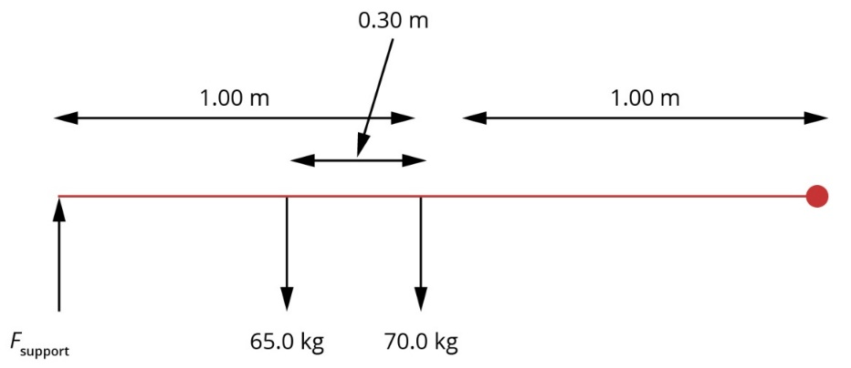

|  |  |
| --- | --- |
| **Description** | **Marks** |
| Sum of clockwise moments = sum of anticlockwise moments | 1 |
|  | 1 |
|  | 1 |
| Answer to 3 significant figures | 1 |

1. What is the force provided by the support at the end of the bed when the 65.0 kg person is sleeping in the bed? **(2 marks)**

|  |  |
| --- | --- |
| **Description** | **Marks** |
| sum of forces up = sum of forces down | 1 |
| 757 + *F*end = (65 + 70) × 9.8 | 1 |
| *F*end = 1323 – 757 = 566 N up | 1 |

**Question 12**

A 75 kg sign is suspended from a uniform 8.5 kg wooden beam of length 2.2 m. The sign is 1.8 m from the wall and a steel cable is attached to the beam 1.5 m from the wall at an angle of 45°.

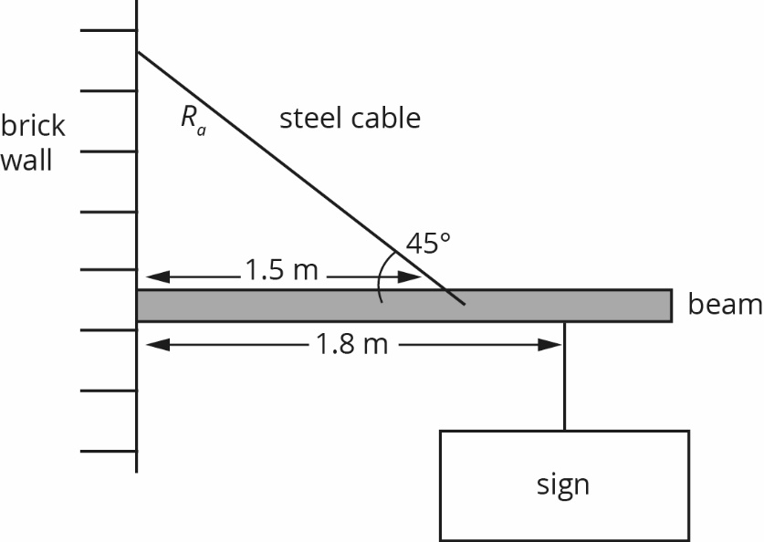

1. State the conditions needed for this structure to be in static equilibrium. **(2 marks)**

|  |  |
| --- | --- |
| **Description** | **Marks** |
| sum of forces up = sum of forces down | 1 |
| sum of clockwise moments = sum of anticlockwise moments | 1 |

1. Determine the tension in the steel cable. **(5 marks)**

|  |  |
| --- | --- |
| **Description** | **Marks** |
| Recognition of pivot point | 1 |
| sum of anticlockwise moments from steel cable = sum of clockwise moments due to weight of beam and sign | 1 |
| *R*a = 1.5 sin 45 = 1.06 m | 1 |
| *TR*a = *m*beam*gr*beam+ *m*sign*gr*sign    = 1.333x103 N | 1  2 |

1. Determine the size and direction of the force supplied by the brick wall on the beam

**(3 marks)**

(2 Marks)

A = 87.6 out from degrees from vertical or 2.39 degrees up from horizontal

(1 Mark)

**Section Three:** Comprehension and data analysis

**Question 13 Satellite Orbits.**

Satellite orbits are "grouped" into general categories because a major characteristic of a particular orbit in the "group" produces a highly desired ground track or an characteristic which is needed to accomplish the main purpose of the satellite.

For example, a communications satellite needs to stay where it can always be seen from the ground, a weather satellite needs to view the earth with the sun in the same relative position every time the satellite passes over a country. Thus, a satellite is placed in an orbit which capitalizes on an aspect of the orbit which helps the satellite achieve its objectives. Regardless of velocity, altitude or other orbital characteristics, all gravitational orbits cut the Earth in half.

* + - 1. **Low Earth Orbit (LEO)**

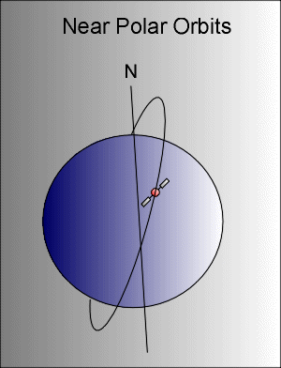Any orbit, in which the satellite completes one full orbit around the earth in less than 225 minutes, is called a "low earth orbit." The reason for the 225 minute definition is the factors which affect the satellite in orbit. Satellites so low that they orbit in fewer than 225 minutes are far more susceptible to the earth's atmosphere and earth gravitational anomalies than any other source of disturbance. Satellites with a period greater than 225 minutes are more likely to be affected by the gravitation of the sun, moon and planets, and the earth's natural radiation belts.

* + - 1. **Polar Orbits**

These orbits have an inclination near 90 degrees. This allows the satellite to see virtually every part of the Earth as the Earth rotates underneath it. It takes approximately 90 minutes for the satellite to complete one orbit. These satellites have many uses such as measuring ozone concentrations in the stratosphere or measuring temperatures in the atmosphere.

* + - 1. **Sun Synchronous Orbits**

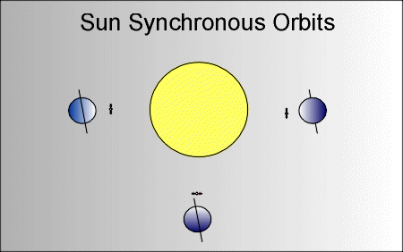These high orbits allows a single satellite to pass over a multiple sections of the Earth at the same time of each day. These satellites orbit at an altitude between 700 to 800 km. These orbits are used for satellites that need a constant amount of sunlight. Satellites that take pictures of the Earth would work best with bright sunlight, while satellites that measure longwave radiation would work best in complete darkness and would face the dark side of the Earth.

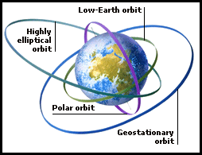

* + - 1. **Geosynchronous and Geostationary Orbits**

A geosynchronous orbit (GSO) is an orbit around the Earth with an orbital period of one day, intentionally matching the Earth's sidereal rotation period. The synchronization of rotation and orbital period means that, for an observer on the surface of the Earth, an object in geosynchronous orbit returns to exactly the same position in the sky after a period of one sidereal day.

A special case of geosynchronous orbit is the geostationary orbit, which is a circular geosynchronous orbit, directly above the equator. A satellite in a geostationary orbit appears stationary, always at the same point in the sky, to ground observers. Communications satellites are often given geostationary orbits, or close to geostationary, so that the satellite antennas that communicate with them do not have to move, but can be pointed permanently at the fixed location in the sky where the satellite appears.

1. The MT SAT-1R is a geostationary satellite. Other than radius/altitude, briefly describe two features of the motion of geostationary satellites and ONE possible use based on these features. **(3 marks)**

|  |  |
| --- | --- |
| **Description** | **Marks** |
| Equatorial Orbit , 24 Hr. period, Fixed Velocity, (any Two) | 2 |
| Uses – Communication , weather (Do not accept GPS etc …) | 1 |

1. Use Kepler’s 3rd law below to explain why all geosynchronous orbits must a fixed altitude of about 35,786 km. No calculation is required.



**(3 marks)**

|  |  |
| --- | --- |
| **Description** | **Marks** |
| For a geosynchronous orbit, Period T is constant at 24hrs. | 1 |
| G, M (mass of the earth and π are constant. | 1 |
| Therefore only one answer for r is possible (i.e. it is also a constant) | 1 |

1. Demonstrate how the formula for Kepler’s 3rd law is derived from other formulae using a series of logical steps.

**(5 Marks)**

|  |  |
| --- | --- |
| **Description** | **Marks** |
| Fc = Fg | 1 |
|  | 1 |
| By substitution of | 1 |
|  | 1 |
| Or the inverse | 1 |

1. Calculate the velocity of a polar orbit.

**(5 Marks)**

|  |  |
| --- | --- |
| **Description** | **Marks** |
| *T = 90 mins = 5400 s* | 1 |
|  | 1 |
|  | 1 |
| Uses formulae with previous answer | 1 |
|  | 1 |

**End of Test**